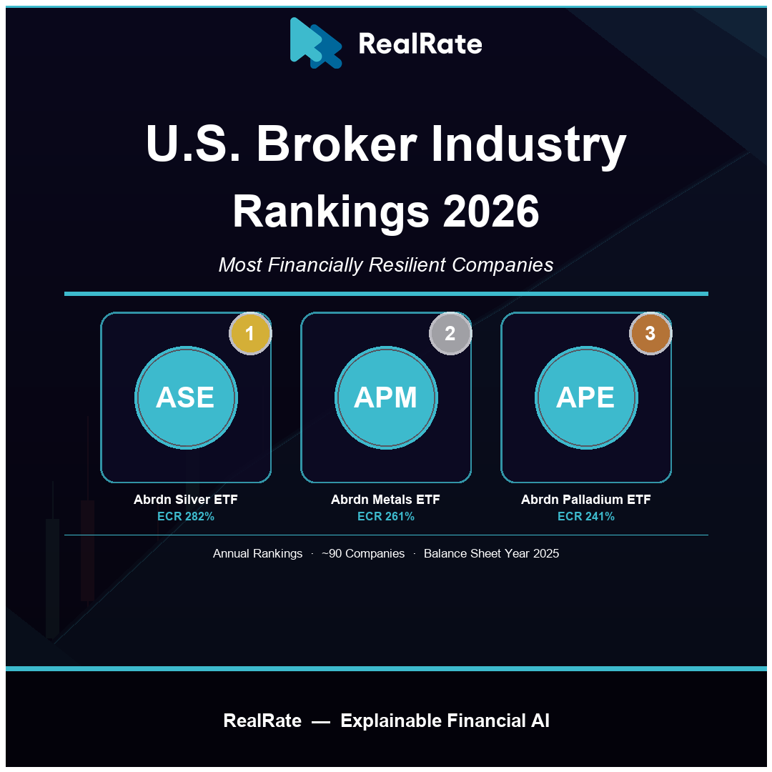

U.S. Broker Industry Rankings 2026: Precious Metals Lead the Capital Strength Race
Abrdn's Silver, Palladium, and Precious Metals ETF Trusts Dominate — While T. Rowe Price Stands Out as the Top Traditional Broker.

Introduction
The U.S. broker industry, as tracked by RealRate, encompasses a remarkably broad range of financial intermediaries — from full-service investment banks and discount brokerages to exchange operators, robo-advisors, and commodity exchange-traded trusts. This breadth makes the sector one of the most structurally diverse in U.S. finance, spanning companies with billions in managed assets and operating revenues alongside passive trust vehicles whose sole business is holding physical precious metals.
The U.S. broker and securities industry generated approximately $530 billion in combined net revenues in 2024, with the largest traditional brokerages — Goldman Sachs, Morgan Stanley, Charles Schwab, and T. Rowe Price — accounting for the majority of operating earnings. The sector has benefited from rising equity markets, higher-for-longer interest rates that boosted net interest income, and growing retail participation in both equities and alternative assets.
RealRate's 2026 rankings assess financial resilience through the Economic Capital Ratio (ECR) — economic value divided by total assets — using audited balance sheet data for fiscal year 2025. The 2026 market average ECR stands at 120%, down from 138% in 2025. The top three ranked companies are all precious metals ETF trusts operated by Abrdn: structurally unique vehicles whose near-zero liabilities and all-equity balance sheets produce ECR values well above any operating company.

2026 Rankings at a Glance
Abrdn Silver ETF Trust claimed first place with an ECR of 282% — 162 percentage points above the 120% industry average. Abrdn Precious Metals Basket ETF Trust ranked second at 261% (+141 pp), and Abrdn Palladium ETF Trust placed third at 241% (+121 pp). SPDR Gold Trust (ETF) follows closely at rank 4 with ECR 236%. Among traditional broker-dealers and investment managers, T. Rowe Price Group stands out as the top operating company at rank 10 with ECR 162% — well above the market average and rivaling many ETF trusts. Rankings were cross-validated between the HTML directory and JSON data sources.
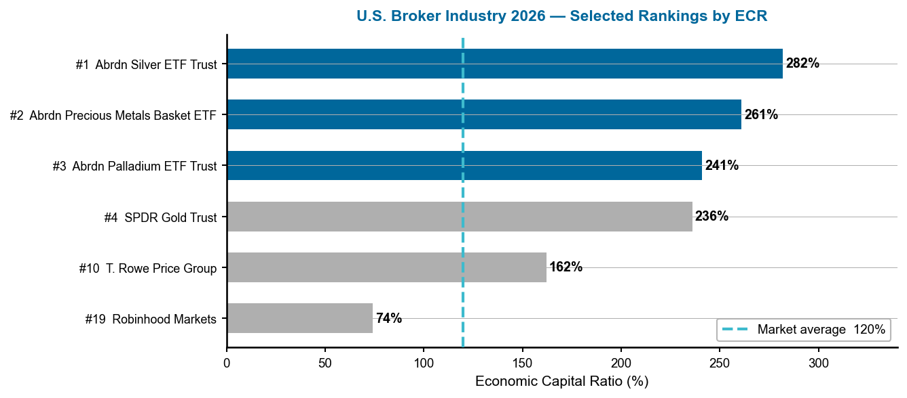
Figure 1 — U.S. Broker Industry 2026: Selected rankings by ECR. Dashed line = 120% market average. Source: RealRate Archive (JSON, 2025).
The ETF trusts dominate because their balance sheets are almost entirely equity — they hold physical precious metals with no operating liabilities. T. Rowe Price at ECR 162% is the standout operating company. Robinhood at 74% shows how newer, growth-stage fintech brokers carry lower capital ratios relative to the industry average.

A Multi-Year Story: Commodity Markets Drive the Rankings
The composition of the top three has shifted dramatically across the past four marketing years, mirroring commodity market cycles. In 2023, U.S. oil funds occupied the top spots as energy prices surged post-pandemic. In 2024, the rally shifted to gold, with Abrdn Gold ETF Trust and SPDR Gold Trust leading the field as gold breached $2,000 per ounce. In 2025, diversified commodity and crypto-linked trusts climbed — with Amplify Commodity Trust reaching ECR 379%. Now in 2026, the silver price rally propels Abrdn Silver ETF Trust to the top of the ranking for the first time, while palladium's market recovery elevates Abrdn Palladium ETF Trust into the top three. Abrdn Silver ETF Trust appeared at rank 7 in 2025 (ECR 210%); its 72-percentage-point jump to 282% reflects both silver's price appreciation and balance sheet expansion.
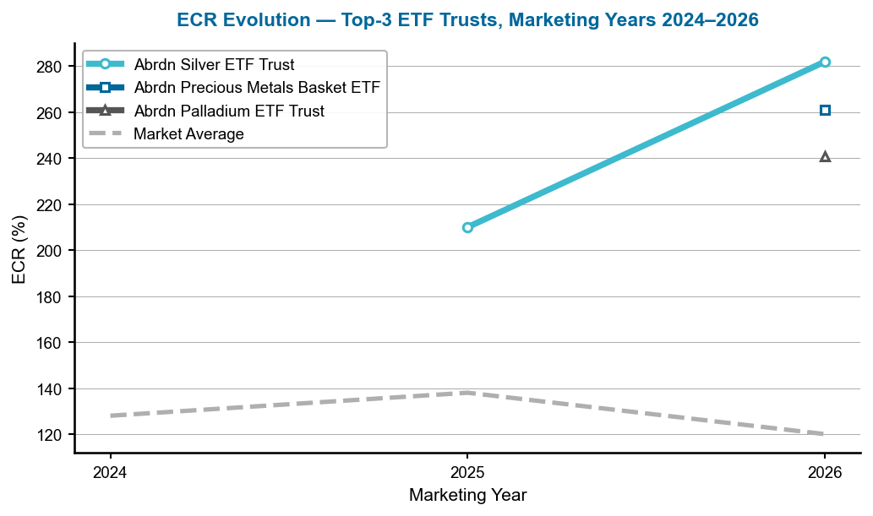
Figure 2 — ECR evolution of the top-3 ETF trusts, marketing years 2024–2026. Dashed grey = market average. Source: RealRate Archive.
Silver ETF's trajectory (210% → 282%) is the steepest ascent. The Precious Metals Basket and Palladium ETFs are new to the top three in 2026, reflecting the broadening of precious metal price strength from gold alone to the full metals complex. The market average declined from 138% to 120% — partly because new, lower-ECR companies entered the ranking universe.

Company Profiles

1. Abrdn Silver ETF Trust — Silver's Equity Machine
Abrdn Silver ETF Trust (ticker: SIVR) holds physical silver bullion. Its balance sheet is the simplest possible: total assets of $5.43 billion (the market value of silver held in custody), liabilities of just $1.4 million (accrued management fees), and stockholders' equity of $5.43 billion. Net income — representing the appreciation of silver's market value in 2025 — totalled $2.84 billion. There are no revenues from customers and no operating expenses beyond the sponsor's fee. The trust is effectively a direct silver price exposure vehicle.
Its ECR of 282% — 162 pp above the market average — reflects an economic capital assessment that accounts for the trust's near-zero leverage, its high-quality assets (physical silver in a LBMA-approved vault), and the strong appreciation in the silver market. The largest positive drivers are ECR before Limited Liability (+167 pp), Liabilities (+106 pp — meaning the trust's liabilities are far below the industry norm), and Net Income (+88.5 pp). The single drag is Other Assets (−105 pp), reflecting silver's price volatility relative to financial assets in the broad market.
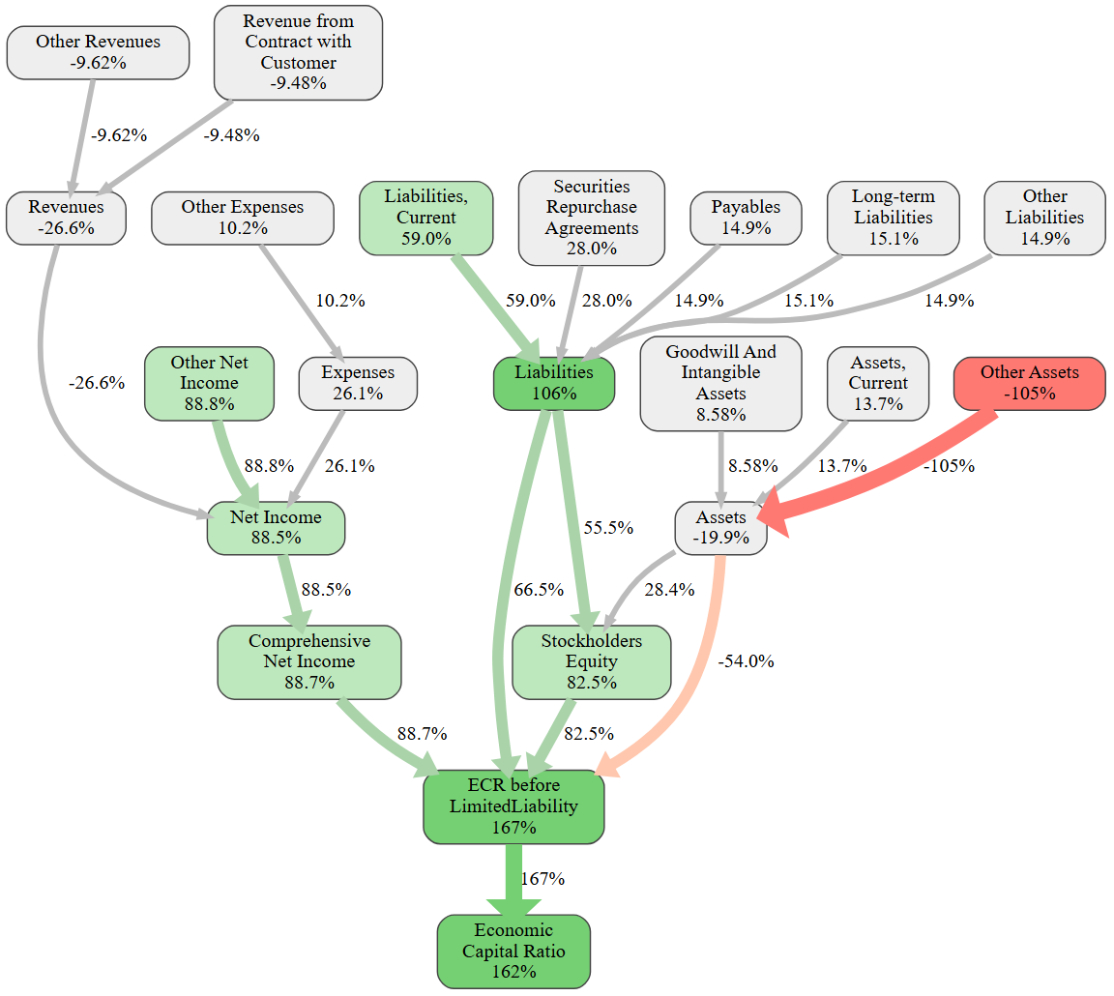
Figure 3 — Abrdn Silver ETF Trust: causal ECR graph. Green = positive, red = negative. Source: RealRate Archive.
The causal graph shows a cascade of positive nodes — ECR b. Ltd. Liability, Liabilities, Net Income, Stockholders' Equity — flowing into a final ECR 162 pp above market. The sole red node, Other Assets (−105 pp), reflects the market's treatment of physical commodity holdings as more volatile than financial assets. Overall, the all-equity, zero-debt structure creates a capital fortress.
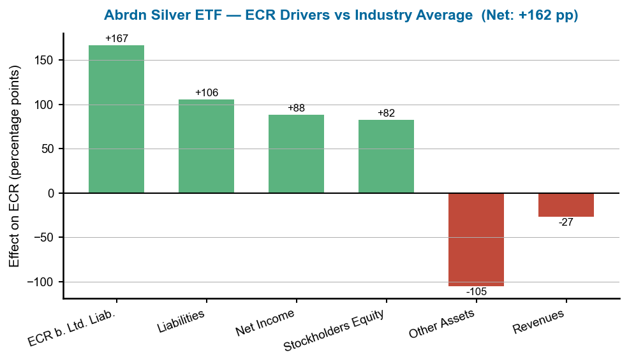
Figure 4 — Abrdn Silver ETF Trust: ECR drivers versus industry average. Source: RealRate Archive.
Four green bars of substantial magnitude (ECR b. Ltd. Liab. +167 pp, Liabilities +106 pp, Net Income +88.5 pp, Stockholders' Equity +82.5 pp) are offset by one large red bar (Other Assets −105 pp). Net: +162 pp above market average — the structural advantage of a debt-free, high-return precious metals vehicle.

2. Abrdn Precious Metals Basket ETF Trust — Diversified Metal Strength
Abrdn Precious Metals Basket ETF Trust (ticker: GLTR) holds a basket of physical gold, silver, platinum, and palladium. Total assets stand at $2.58 billion, liabilities at $1.3 million, and net income (underlying metal appreciation) at $1.07 billion for 2025. The diversified nature of its holdings — combining gold's stability with silver's and palladium's cyclical upside — produced a strong ECR of 261%, placing it 141 pp above the industry average.
The trust's ECR profile mirrors Silver ETF's structurally, with ECR before Limited Liability (+145 pp), Liabilities (+93.1 pp), and Stockholders' Equity (+85.9 pp) as the leading positive drivers. The Other Assets drag (−94.6 pp) is slightly smaller, reflecting gold's lower historical volatility anchoring the basket.
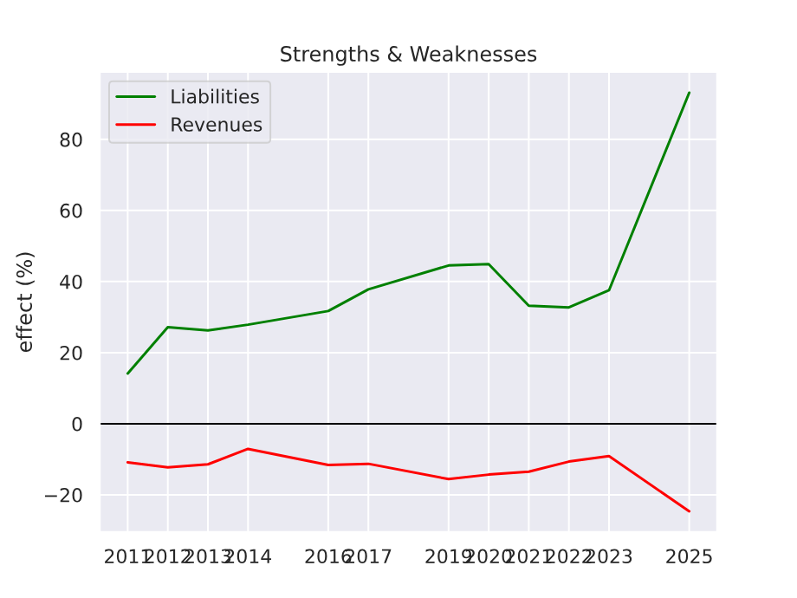
Figure 5 — Abrdn Precious Metals Basket ETF Trust: ECR strengths and weaknesses over time. Source: RealRate Archive.
The strengths-over-time chart shows a consistent pattern of structural positives: the trust's near-zero liabilities and all-equity structure deliver recurring positive contributions year after year. The temporary weakness from the Other Assets classification narrows when metals markets outperform, as in 2025.
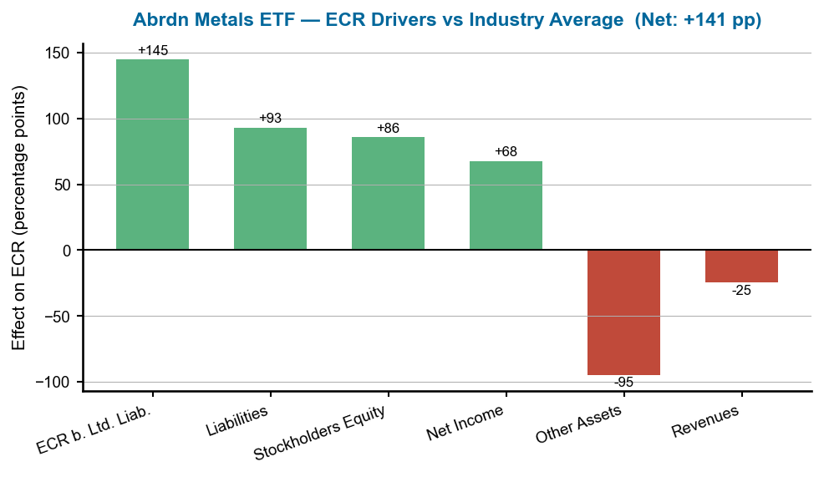
Figure 6 — Abrdn Precious Metals Basket ETF Trust: ECR drivers versus industry average. Source: RealRate Archive.
The bar chart mirrors Silver ETF's pattern but at scaled magnitudes — ECR b. Ltd. Liability (+145 pp), Liabilities (+93.1 pp), Equity (+85.9 pp) — with Other Assets (−94.6 pp) the principal offset. The diversified basket gives slightly more stable contributions than single-metal vehicles. Net: +141 pp above market average.

3. Abrdn Palladium ETF Trust — Rarest Metal, Cleanest Balance Sheet
Abrdn Palladium ETF Trust (ticker: PALL) holds physical palladium, the rarest of the four major precious metals. Total assets are $1.04 billion, liabilities just $0.5 million, and net income $321.9 million for 2025. With palladium recovering from multi-year lows, the trust's ECR reached 241% — 121 pp above the market average. As the smallest of the three Abrdn trusts by AUM, PALL's entry into the top three reflects both its ultra-clean capital structure and the palladium market's 2025 recovery.
Stockholders' Equity (+87.7 pp) is the top individual driver — the highest equity contribution of the three Abrdn trusts — while ECR before Limited Liability (+125 pp) and Liabilities (+81.4 pp) provide the structural foundation. Other Assets (−81.1 pp) is the primary drag, smaller in magnitude than in the Silver or Metals Basket ETFs, consistent with palladium's more industrial (and less purely financial) nature.
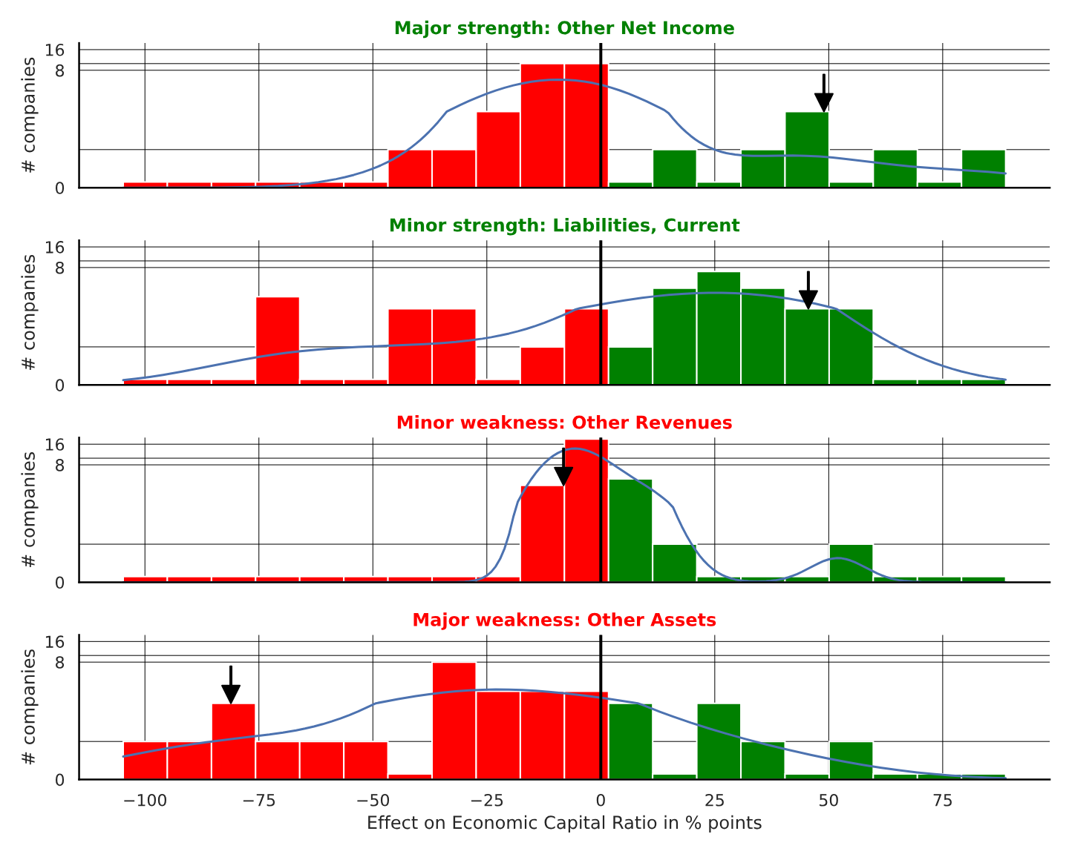
Figure 7 — Abrdn Palladium ETF Trust: feature distribution (black arrow marks the trust's position relative to industry distribution). Source: RealRate Archive.
The feature distribution chart positions Palladium ETF Trust at the far right (highest end) of the ECR distribution, consistent with its rank-3 position. The black arrow points well beyond the central mass of the ~90-company distribution, illustrating how structurally distinct ETF trusts are from operating broker-dealers.
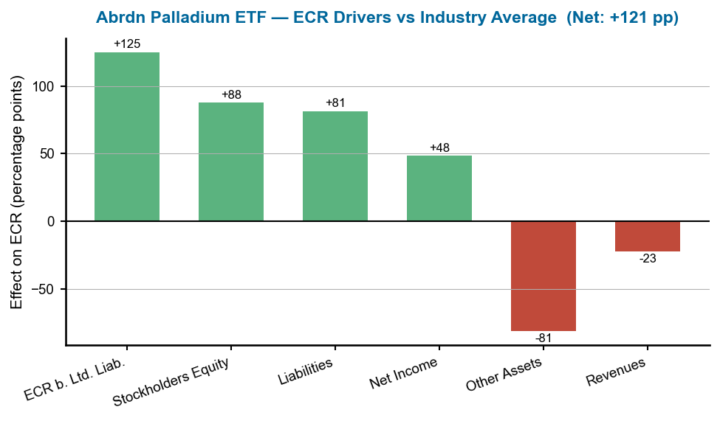
Figure 8 — Abrdn Palladium ETF Trust: ECR drivers versus industry average. Source: RealRate Archive.
Three strong green bars (ECR b. Ltd. Liab. +125 pp, Equity +87.7 pp, Liabilities +81.4 pp) offset by one red bar (Other Assets −81.1 pp). Net: +121 pp above market. The equity driver being the highest of the three trusts reflects palladium's recent price recovery translating to strong balance sheet growth.

What Drives Financial Strength in U.S. Brokerage?
RealRate's model identifies ECR before Limited Liability (95% importance) and Stockholders' Equity (89.1%) as the two dominant determinants — confirming that capital structure is the primary differentiator. Liabilities (72.3%) and Other Assets (53.4%) follow, with Liabilities, Current (51.4%) rounding out the top five. Revenue-side variables (27.9%) and expense variables (20.6%) rank lower, suggesting that in this industry, how a company is financed matters far more than how much it earns in any given year. This dynamic explains why asset-light, debt-free trust vehicles consistently outperform even highly profitable broker-dealers.
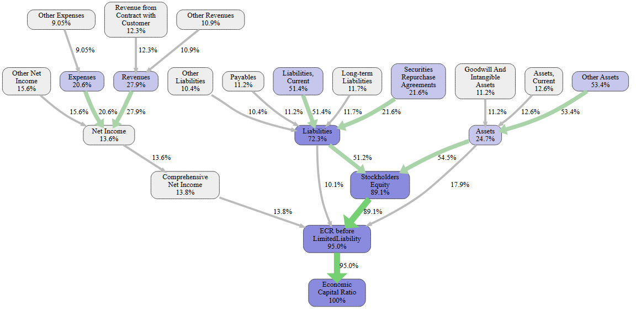
Figure 9 — U.S. Broker Industry: feature importance cascade for ECR prediction (industry-level). Source: RealRate Archive.
ECR before Limited Liability (95%) and Stockholders' Equity (89.1%) dominate, followed by Liabilities (72.3%) — all balance sheet variables. Revenue and expense variables cluster below 30%. This confirms: in the broker sector, capital structure explains financial strength far better than income statement performance.
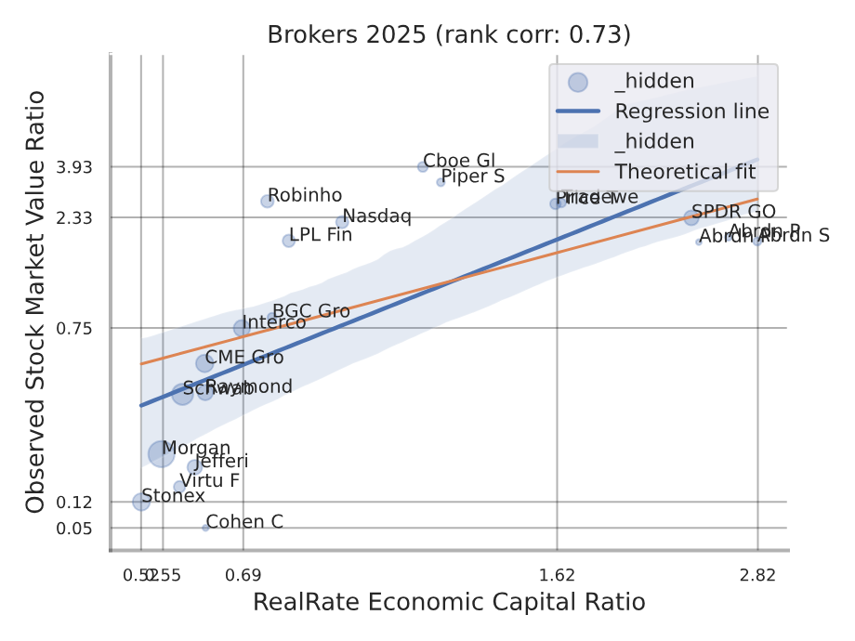
Figure 10 — U.S. Broker Industry: backtesting correlation — ECR vs. observed market value ratio (industry-level). Source: RealRate Archive.
The upward-sloping regression confirms ECR is a meaningful predictor of market valuation across the ~90-company U.S. broker universe. The scatter is wide — reflecting the structural diversity from ETF trusts at one extreme to leveraged broker-dealers at the other — but the trend is clear: higher ECR companies command higher market valuations relative to their asset base.

Market Statistics
The market average ECR for the U.S. broker industry in 2026 stands at 120%, down from 138% in 2025 and 128% in 2024. This decline partly reflects the expansion of the ranking universe to include more operating broker-dealers with lower ECRs, and partly a broader recalibration of economic capital assessments as interest rates remain elevated and credit costs rise. The spread between the top performer (282%) and the market average (120%) is 162 pp — the widest in any U.S. industry tracked by RealRate, driven by the structural gulf between ETF trusts and operating companies.
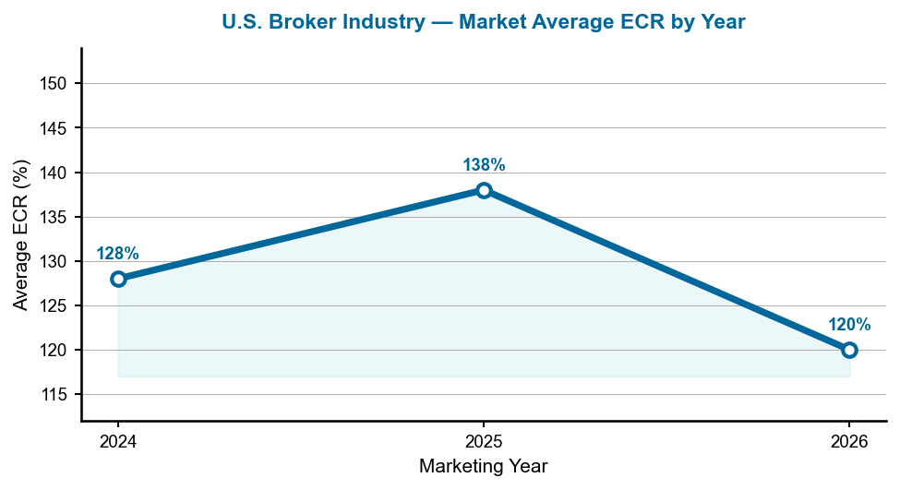
Figure 11 — Average ECR for the U.S. broker industry, marketing years 2024–2026.
The dip from 138% to 120% in 2026 may reflect a compositional shift: as the ETF trust sector expands (more trusts, more metals categories), their very high ECRs are offset by the entry of more operating companies with typical leverage structures. The overall trend suggests the broker universe is broadening.

Notable Movers: Traditional Brokers
Among operating companies, T. Rowe Price Group is the standout at rank 10 with ECR 162% — the only traditional broker to match ETF trust territory. Its fee-based asset management model, minimal leverage, and strong equity base make it structurally closest to the ETF trust model among operating broker-dealers. Robinhood Markets rises to rank 19 with ECR 73.79% — a significant improvement from its debut ranking in 2020. Its simple, app-based business model and low debt load drive an above-average ECR. Nasdaq Inc. ranks 15th at 90.58%, benefiting from its exchange-operator margins and diversified data business. Charles Schwab placed 25th at 58.49%, reflecting the impact of its large deposit franchise and interest-rate sensitivity on the balance sheet. Interactive Brokers, at rank 38 with ECR 57.33%, has improved steadily since its 2012 entry at rank 92, as its low-cost operating model continues to strengthen its capital position.

Manager's Takeaway
RealRate's 2026 U.S. Broker Industry Rankings offer two parallel stories. The dominant story is commodity market structure: precious metals ETF trusts occupy the top ranks because their balance sheets are essentially indistinguishable from the commodity they hold — zero debt, total equity, no operating risk. As silver and palladium markets strengthened in 2025, Abrdn's suite of ETF trusts rose accordingly. The secondary story is more instructive for operating companies: T. Rowe Price, with its fee-based, low-leverage model, demonstrates that a traditional broker can achieve ETF-trust-level capital ratios through disciplined balance sheet management. For Schwab, Robinhood, and Interactive Brokers, the rankings confirm a convergence trend — newer and more capital-efficient operating models are climbing steadily. In a sector where leverage can amplify both gains and losses, the ECR remains the clearest measure of who will still be standing through the next market cycle.

