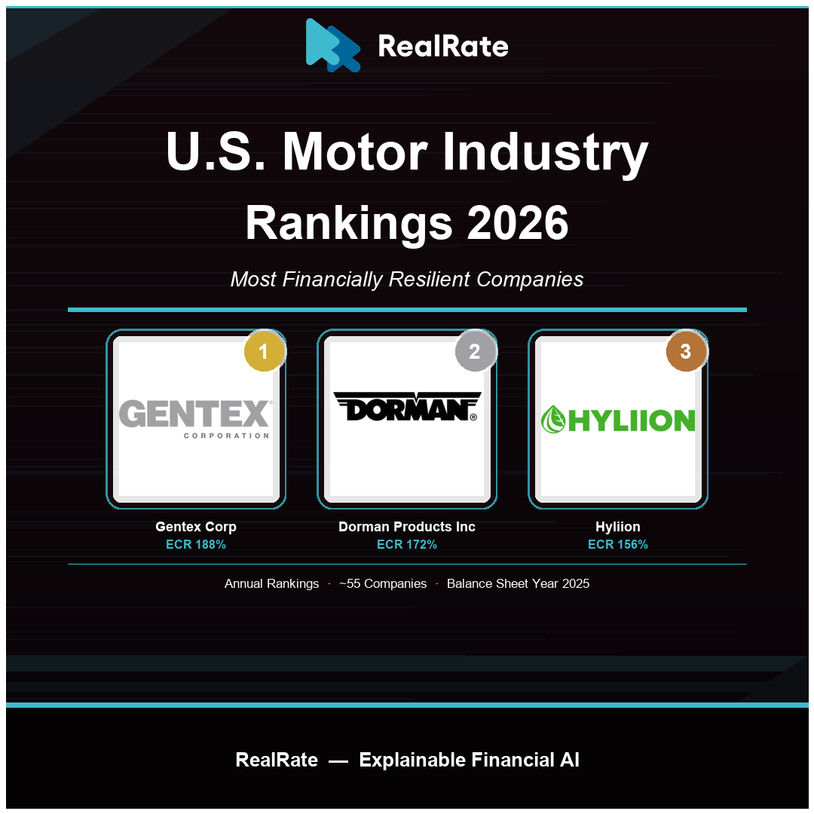

U.S. Motor Industry Rankings 2026: Gentex Holds the Wheel While EV Challengers Reshape the Field
Gentex CORP Leads with ECR 188%, Dorman Products Climbs to Second — as Hyliion's Cash-Rich Balance Sheet Defies Its Startup Revenue Profile.

Introduction
The U.S. motor industry — spanning automakers, Tier-1 components suppliers, EV manufacturers, and emerging automotive technology companies — generated approximately $670 billion in combined revenues in 2024, anchored by the vertically integrated operations of General Motors, Ford, and Tesla, alongside a deep ecosystem of specialized suppliers. Rising EV penetration, persistent supply chain realignment post-pandemic, and shifting consumer preferences have made balance sheet strength more critical than ever as manufacturers navigate heavy capital expenditure cycles.
RealRate's 2026 ranking assesses financial resilience through the Economic Capital Ratio (ECR) — economic value divided by total assets — using audited balance sheet data for fiscal year 2025. The market average ECR for the U.S. motor industry stands at 101%, up from 97% in 2025 and 93% in 2024, signaling gradual overall capital improvement. Topping the rankings for the fourth consecutive year is Gentex CORP, the Michigan-based auto-dimming mirror and driver-assistance electronics specialist, with an ECR of 188% — 87 percentage points above the industry average.

2026 Rankings at a Glance
Gentex CORP leads at ECR 188%, retaining the top position it first claimed in 2010. Dorman Products Inc — the aftermarket auto parts specialist — advances to second place with ECR 172%, having ranked third in 2025. Hyliion Holdings Corp, the Houston-based electric powertrain developer, enters the top three for the first time with ECR 156%, despite recording zero product revenues in 2025. Tesla Inc holds ninth place at ECR 135%, reflecting its strengthened balance sheet as net income became consistently positive. Ford Motor Co ranks 30th at ECR 74%, while Rivian Automotive sits at 31st with ECR 70%, still building scale. Rankings were cross-validated between the RealRate HTML directory and JSON data sources.
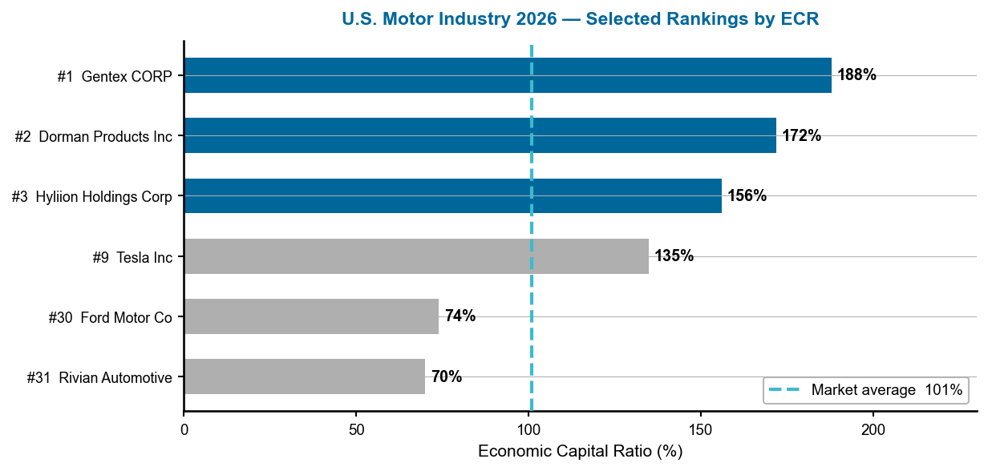
Figure 1 — U.S. Motor Industry 2026: Selected rankings by ECR. Dashed line = 101% market average. Source: RealRate Archive (JSON, 2025).
The spread between the top performer (Gentex, 188%) and the market average (101%) is 87 pp — driven by Gentex's asset-light, high-margin model. The gap between Tier-1 specialists (Gentex, Dorman) and the large OEMs (Ford, Rivian) illustrates how capital-intensive vehicle manufacturing compresses ECR relative to components and software-adjacent suppliers.

Three Years of Steady Gains — and One Dramatic Shift
Gentex has remained the most financially resilient company in the U.S. motor industry across multiple ranking cycles, though its ECR has modestly declined from 201% in both 2024 and 2025 (marketing years) to 188% in 2026 — reflecting higher cost of goods sold as supply chain pressures increased input costs. Dorman Products maintained a consistent presence in the top three, with ECR moving from 165% in 2025 to 172% in 2026 as its aftermarket focus and disciplined balance sheet compounded. The most notable shift is Hyliion: the company's ECR fell from 164% in 2025 to 156% in 2026 as cash reserves were deployed into R&D, yet its equity-heavy structure kept it firmly in the top three. The market average has steadily improved: 93% in 2024, 97% in 2025, 101% in 2026 — a positive signal for the industry's overall financial health.
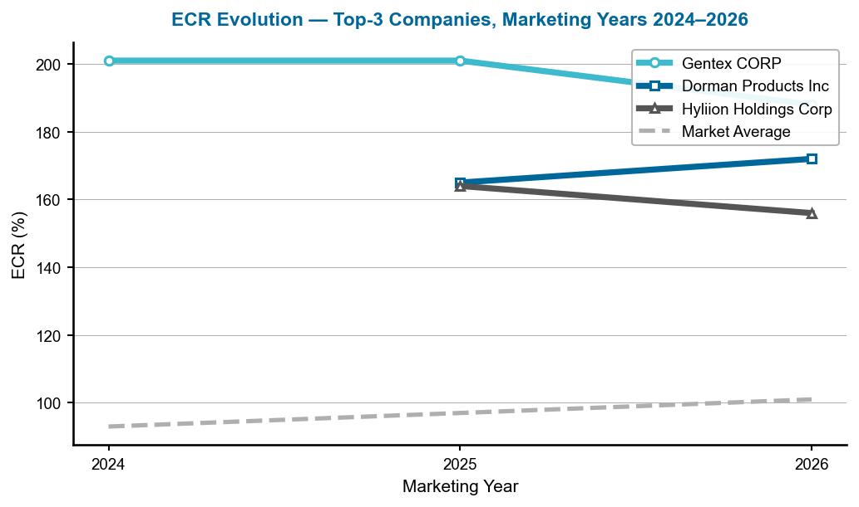
Figure 2 — ECR evolution of the top-3 companies, marketing years 2024–2026. Dashed grey = market average. Source: RealRate Archive.
Gentex's slight ECR decline (201% → 188%) is not a structural weakness — it reflects a temporary rise in production costs. Dorman's improvement (165% → 172%) is driven by stronger equity accumulation and debt reduction. Hyliion's small decline (164% → 156%) is consistent with pre-revenue phase cash consumption. All three remain well above the rising market average.

Company Profiles

1. Gentex CORP — The Perennial Capital Champion
Gentex CORP (GNTX) designs and manufactures auto-dimming rearview mirrors, camera-based driver monitoring systems, and HomeLink wireless controls, supplying virtually every major OEM globally. Its 2025 balance sheet shows total assets of $2.93 billion, liabilities of just $437.7 million, stockholders' equity of $2.49 billion, revenues of $2.53 billion, and net income of $384.7 million. Its business model — high-margin, IP-protected components with no vehicle manufacturing exposure — produces one of the cleanest capital structures in the entire U.S. motor sector.
Gentex's ECR of 188% places it 87 percentage points above the 101% industry average. The greatest strength is Stockholders' Equity (+65 pp), followed closely by Liabilities (+53 pp) — meaning its debt load is far below the industry norm. Net Income (+43 pp) further compounds the advantage. The single meaningful drag is Cost of Goods Sold (−30 pp), reflecting higher input costs for the glass and electronics components in its product lines.
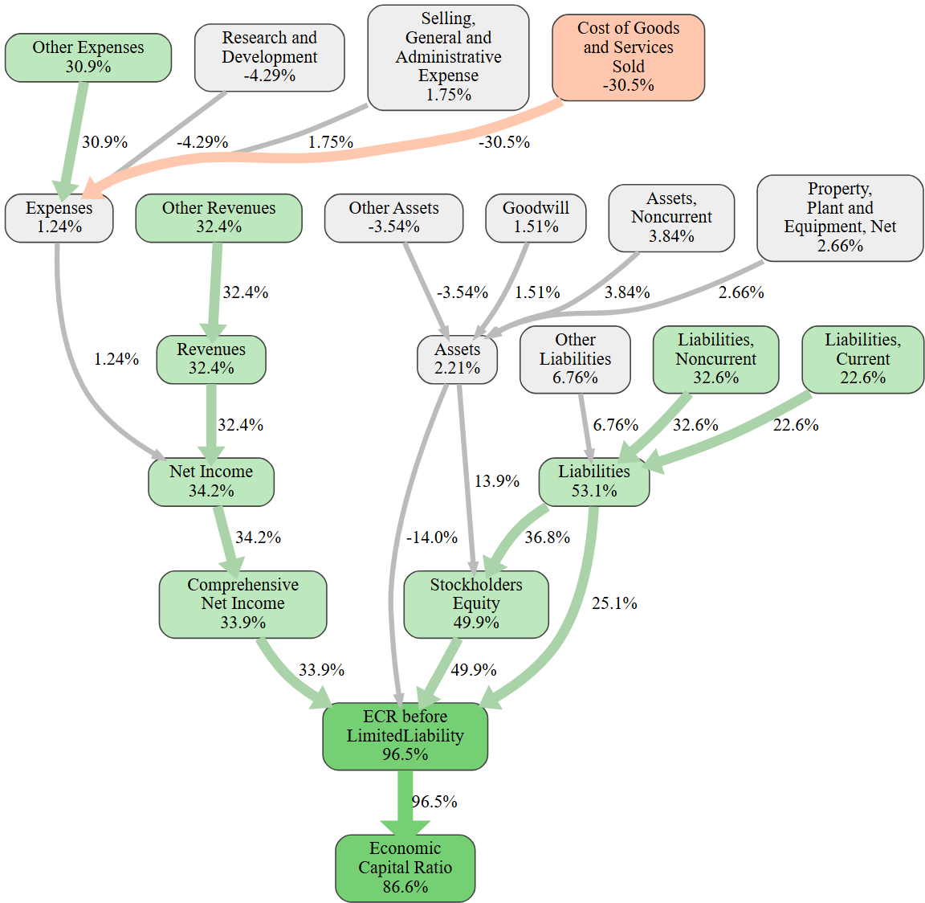
Figure 3 — Gentex CORP: causal ECR graph. Green = positive factors, red = negative. Source: RealRate Archive.
The causal graph shows a cascade of positive nodes — Stockholders' Equity, Liabilities, Net Income — flowing into an ECR 87 pp above the market average. The red node for COGS is the primary constraint: Gentex's high production costs for precision optical and electronic components compress margins modestly but do not undermine its fortress-like capital position.
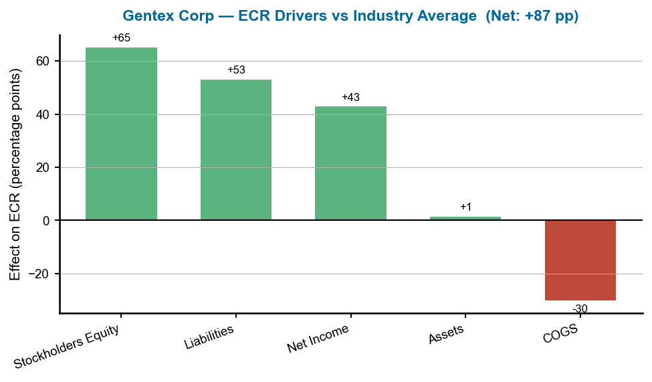
Figure 4 — Gentex CORP: ECR drivers versus industry average. Source: RealRate Archive.
Three strong green bars (Equity +65 pp, Liabilities +53 pp, Net Income +43 pp) dominate the chart, with one moderate red bar (COGS −30 pp). Net: +87 pp above the industry average. The equity and liability structure is the bedrock — Gentex has built a balance sheet that the capital-intensive OEMs cannot match.

2. Dorman Products Inc — The Aftermarket Advantage
Dorman Products (DORM) is an aftermarket auto parts supplier with more than 135,000 SKUs covering chassis, powertrain, electrical, and HVAC components. Its 2025 balance sheet shows total assets of $2.49 billion, liabilities of $492.8 million, equity of $2.00 billion, revenues of $2.13 billion, and net income of $204.2 million. Dorman benefits from a structural tailwind: the aging U.S. vehicle fleet (average age 12.6 years) drives consistent aftermarket demand regardless of new vehicle sales cycles. This stability translates directly into a disciplined balance sheet and predictable cash generation.
With ECR of 172% — 71 pp above the industry average — Dorman's strength lies in its low liability profile (+43 pp) and substantial stockholders' equity (+41 pp). Net income contributes a further +27 pp. The principal drag is also COGS (−17 pp), consistent with the competitive pricing environment in aftermarket parts, though Dorman's proprietary parts development model keeps this cost pressure manageable.
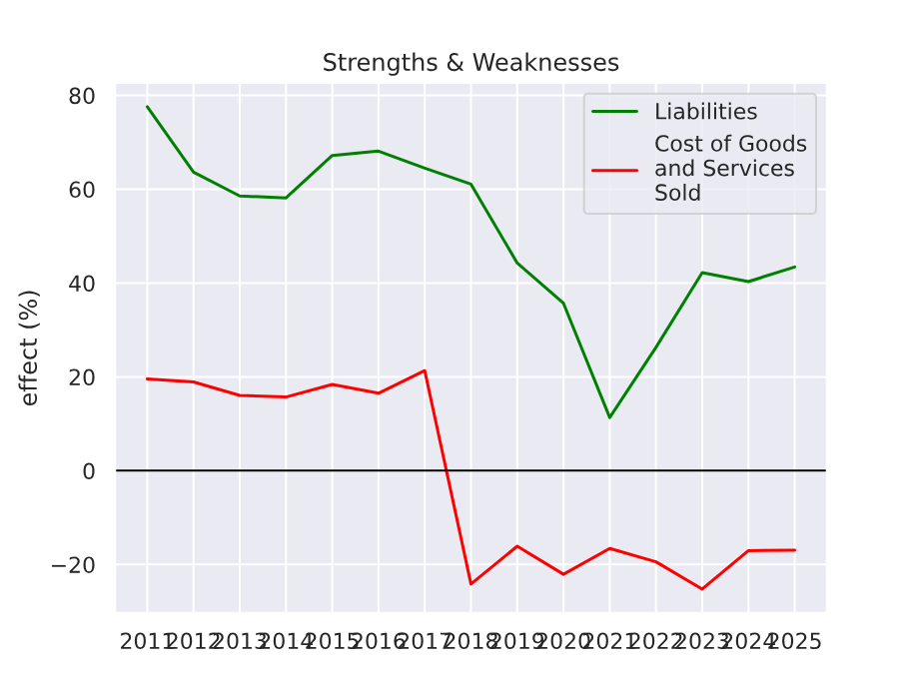
Figure 5 — Dorman Products Inc: strengths and weaknesses over time. Source: RealRate Archive.
The strengths-over-time chart shows Dorman's liability advantage and equity strength as recurring positives year after year. The COGS weakness has remained fairly stable, reflecting the competitive but predictable nature of aftermarket pricing. Dorman's consistent profile confirms its model delivers durable financial resilience — not cyclical peaks.
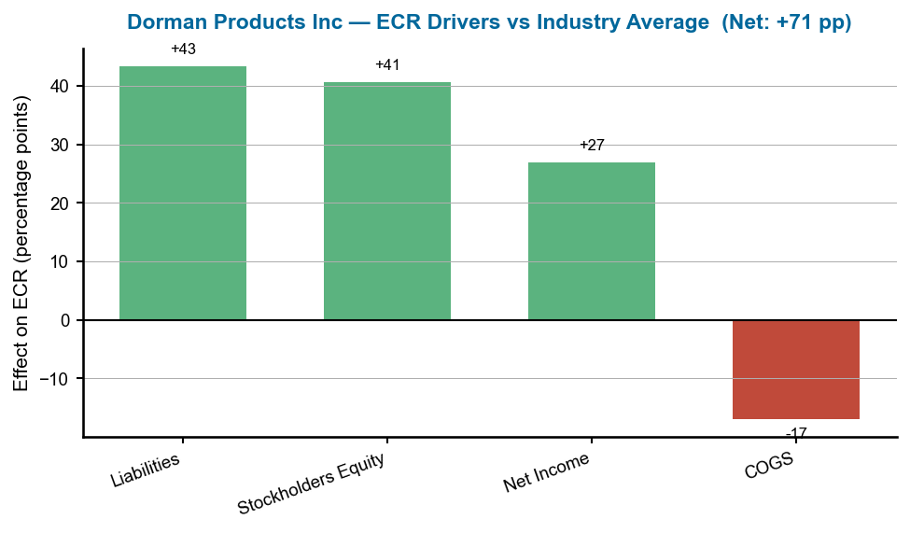
Figure 6 — Dorman Products Inc: ECR drivers versus industry average. Source: RealRate Archive.
Three green bars (Liabilities +43 pp, Equity +41 pp, Net Income +27 pp) against one red bar (COGS −17 pp). Net: +71 pp above average. The balance between liability and equity contributions is remarkably even — a sign of a well-managed capital structure rather than one skewed by a single exceptional factor.

3. Hyliion Holdings Corp — The Pre-Revenue Paradox
Hyliion Holdings (HYLN) is a pre-commercial electric powertrain company developing the Karno generator — a heat engine platform for heavy transport. Its 2025 financials present an unusual picture: total assets of $351.9 million, total liabilities of $294.2 million (primarily deferred revenue and deposits), stockholders' equity of just $57.6 million, zero product revenues, and a net loss of $58.9 million. Yet despite these numbers, its ECR reaches 156% — 55 pp above the market average. The explanation lies in how RealRate's model weights economic capital relative to the size of assets: Hyliion's large cash and investment reserves relative to its small asset base produce an unusually high ECR for a company still in development phase.
The dominant positive driver is Stockholders' Equity (+93 pp) — reflecting the remaining cash from prior capital raises held as liquid assets. Assets (+53 pp) and Liabilities (+32 pp) also contribute positively. The primary drags are Other Revenues (−39 pp) — the model penalizes companies with zero or negative revenue relative to peers — and Net Income (−25 pp), reflecting the ongoing operating loss.
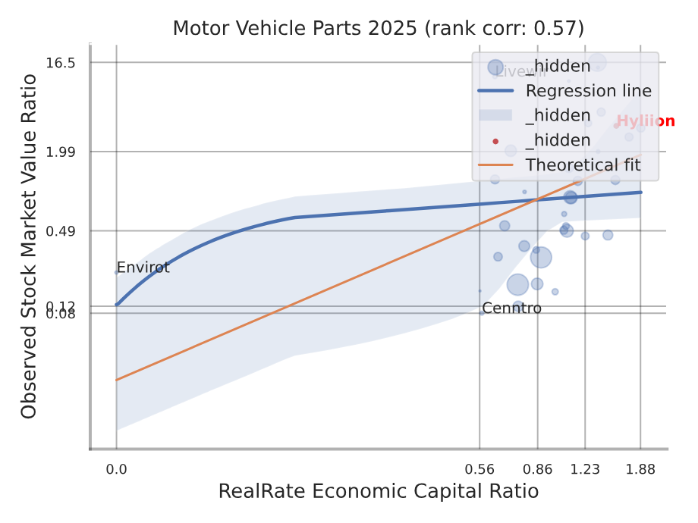
Figure 7 — Hyliion Holdings Corp: backtesting correlation scatter (red dot marks Hyliion's position relative to the industry distribution). Source: RealRate Archive.
The backtesting scatter positions Hyliion at the upper end of the ECR range despite its atypical revenue profile. The red dot reflects a company whose economic capital is assessed high relative to market value — consistent with a pre-revenue development company whose balance sheet value may not yet be fully reflected in market capitalization. This is the tension in Hyliion's top-3 position: strong capital structure, uncertain commercial trajectory.
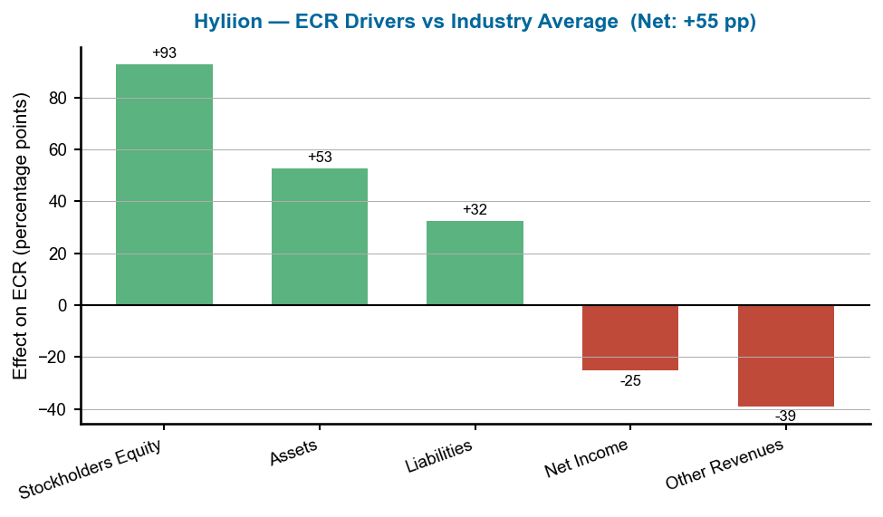
Figure 8 — Hyliion Holdings Corp: ECR drivers versus industry average. Source: RealRate Archive.
Two large green bars (Equity +93 pp, Assets +53 pp) and one moderate green bar (Liabilities +32 pp) are partially offset by two red bars (Other Revenues −39 pp, Net Income −25 pp). Net: +55 pp above average. The chart captures Hyliion's core paradox — exceptional balance sheet capital, zero revenue. For investors, the question is whether the Karno platform can convert that capital into cash-generating operations before the reserves deplete.

What Drives Financial Strength in U.S. Motors?
RealRate's model identifies Stockholders' Equity (99.2% importance) as the single most powerful predictor of ECR in the U.S. motor sector — confirming that balance sheet solidity, not earnings quality, is the primary differentiator. Cost of Goods Sold (94.9%) and Other Expenses (92.7%) follow closely, underscoring that cost structure is the most penalizing factor for companies that cannot control manufacturing and supply chain costs. ECR before Limited Liability (89.2%) and Comprehensive Net Income (88.6%) round out the top five. Revenue-side variables (69.6%) rank lower, reflecting that in an industry where capital intensity is the defining characteristic, how a company finances its assets matters more than how much it earns in any one year.
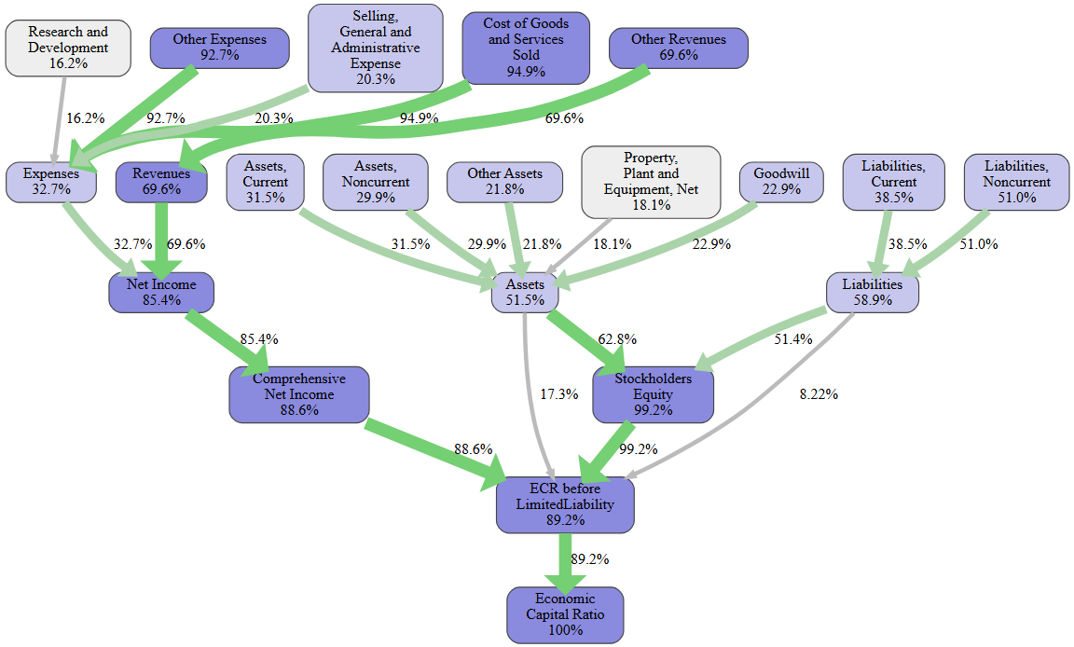
Figure 9 — U.S. Motor Industry: feature importance cascade for ECR prediction (industry-level). Source: RealRate Archive.
Stockholders' Equity at 99.2% importance dominates all other variables — nearly at maximum. COGS (94.9%) and Other Expenses (92.7%) as the second and third most important variables confirm: cost control is the key lever for companies unable to match the equity strength of asset-light suppliers like Gentex and Dorman. Net Income (85.4%) and Revenues (69.6%) rank lower, confirming balance sheet composition outweighs income statement performance.
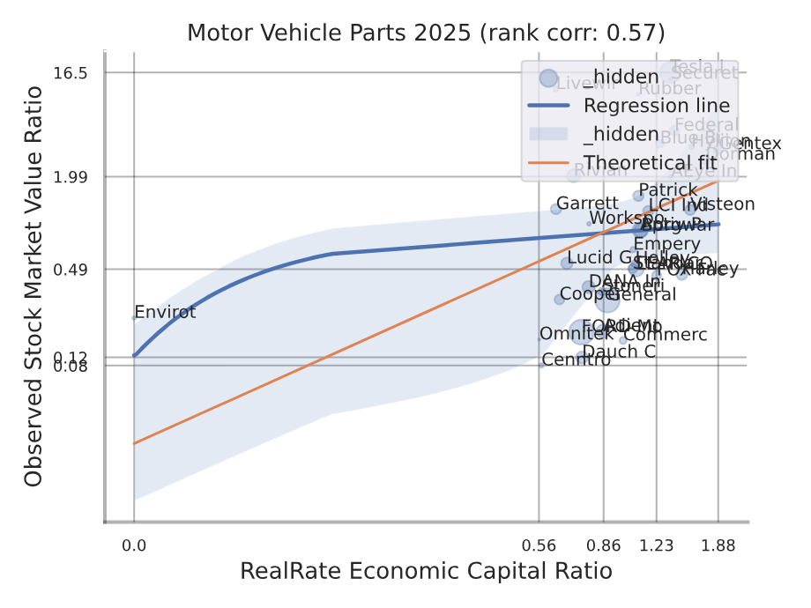
Figure 10 — U.S. Motor Industry: backtesting correlation — ECR vs. market value ratio (industry-level). Source: RealRate Archive.
The upward-sloping regression confirms ECR is a meaningful predictor of market valuation across the ~55-company U.S. motor universe. The scatter is moderate — reflecting the diversity from asset-light components suppliers at one extreme to capital-heavy OEMs at the other — with a clear positive trend: companies with higher ECR command higher valuations relative to assets.

Market Statistics
The market average ECR for the U.S. motor industry in 2026 stands at 101%, up from 97% in 2025 and 93% in 2024. This three-year upward trend reflects improving balance sheet health across the sector: OEMs have reduced leverage accumulated during pandemic-era supply disruptions, Tier-1 suppliers have rebuilt equity buffers, and EV companies that raised large equity rounds in 2020–2022 still carry those reserves on their balance sheets. The spread between the top performer (Gentex, 188%) and the market average (101%) of 87 pp reflects the structural advantage of asset-light, high-margin components businesses over vehicle manufacturers.
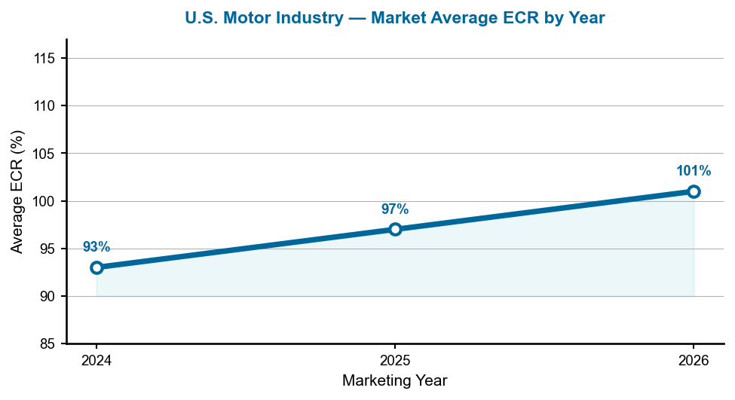
Figure 11 — U.S. Motor Industry: average ECR by marketing year, 2024–2026.
The steady rise from 93% to 101% over three years is encouraging — but the pace suggests incremental balance sheet repair rather than a structural transformation. For the average U.S. motor company, ECR remains at parity with the 100% threshold, meaning economic capital roughly equals total assets. Companies below this threshold carry economically leveraged positions that could amplify losses in a demand downturn.

Notable Movers: From Legacy OEMs to EV Disruptors
Tesla Inc's rise from rank 39 in 2011 to rank 9 in 2026 — with ECR now at 135% — is the most dramatic long-term trajectory in the U.S. motor rankings. Tesla's transition from a cash-burning startup to a consistently profitable automaker with a lean balance sheet has steadily lifted its ECR toward the top tier. General Motors holds a mid-table position with ECR near the market average, reflecting its mixed profile: strong revenues but persistent leverage from pension obligations and capital-heavy manufacturing footprint. Ford Motor Co at rank 30 (ECR 74%) faces similar structural constraints, amplified by its aggressive EV investment program that compresses near-term equity ratios. Rivian Automotive at rank 31 (ECR 70%) has seen its development-phase cash reserves shrink as production ramp costs accelerate — a dynamic that could further pressure its ECR over the next two years unless revenue growth catches up. At the other end of the spectrum, Ameritek Ventures — which topped the 2025 rankings with ECR 204% — does not appear in the top three in 2026, underscoring how volatile the upper ranks can be for smaller, less-diversified companies.

Manager's Takeaway
RealRate's 2026 U.S. Motor Industry Rankings tell a story with two distinct chapters. The first is the dominance of asset-light, specialty suppliers: Gentex and Dorman — both companies with deep IP moats, disciplined cost structures, and minimal debt — continue to outperform the broader industry by wide margins because their business models avoid the capital intensity that compresses ECR for OEMs. The second chapter is the EV paradox: Hyliion holds third place on balance sheet strength derived from pre-commercial capital reserves, while Rivian — further along the commercialization path but burning cash at scale — ranks 31st. This gap captures the precise moment where EV companies transition from capital-flush startups to operationally stressed manufacturers. Tesla's rank-9 position shows that the transition is achievable — but it requires sustained profitability over multiple years to rebuild the equity base that development-phase spending consumes. For companies, suppliers, and investors, the ECR ranking is a forward-looking signal: the businesses positioned to weather the next industry cycle are those whose balance sheets are strongest today.

